**Assignment No:-30**

Name:-Suryawanshi Sangramsingh Sambhaji

Batch: - Delta - DCA (Java) 2024 Date:-18/6/2024

**Q1.Write a Java program to find last occurrence of a character in a given string.**

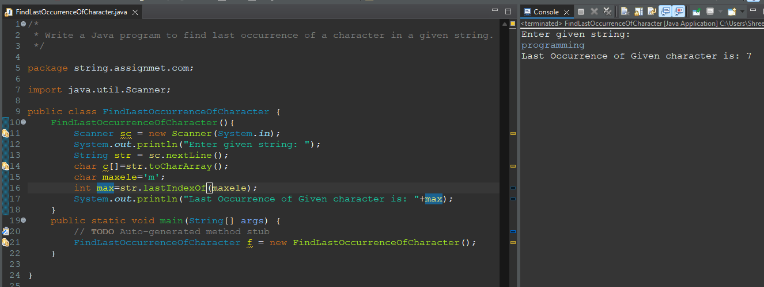

**Q2.Write a Java program to find highest frequency character in a string.**

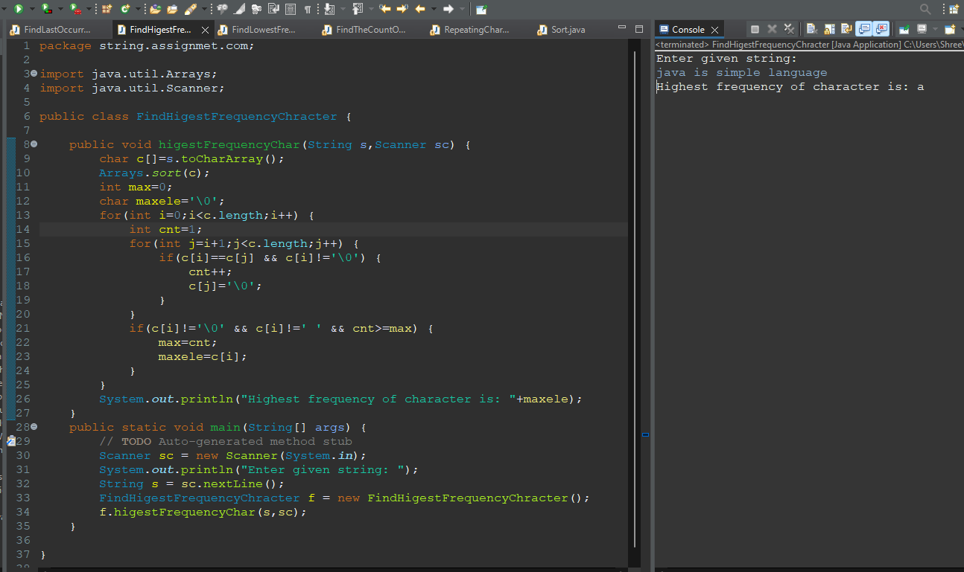

**Q3.Write a Java program to find lowest frequency character in a string.**

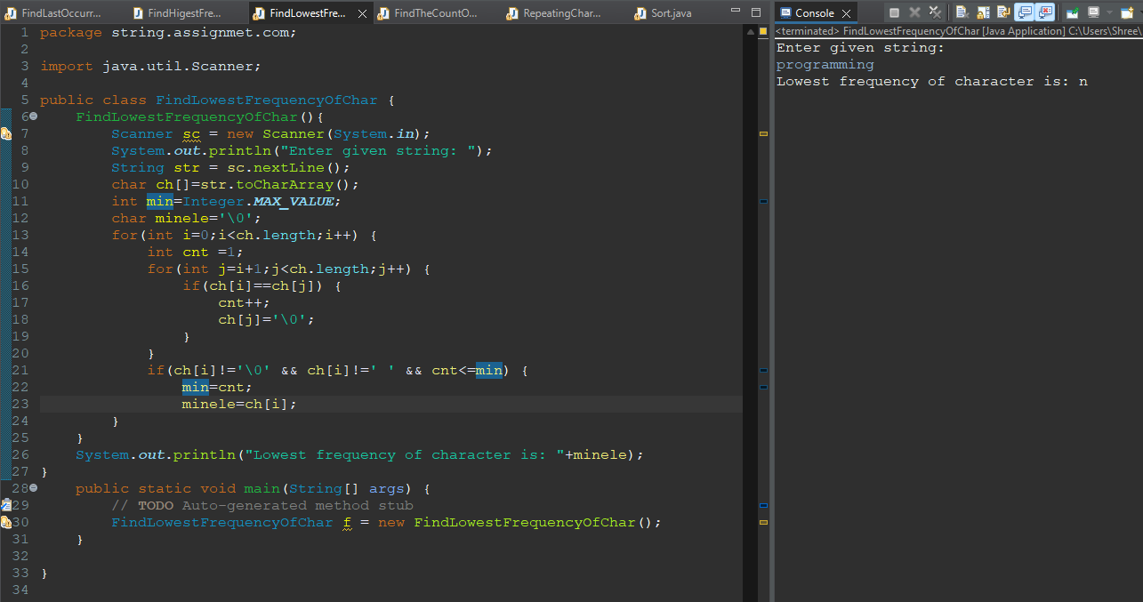

**Q4.Write a Java program to count frequency of each character in a string.**

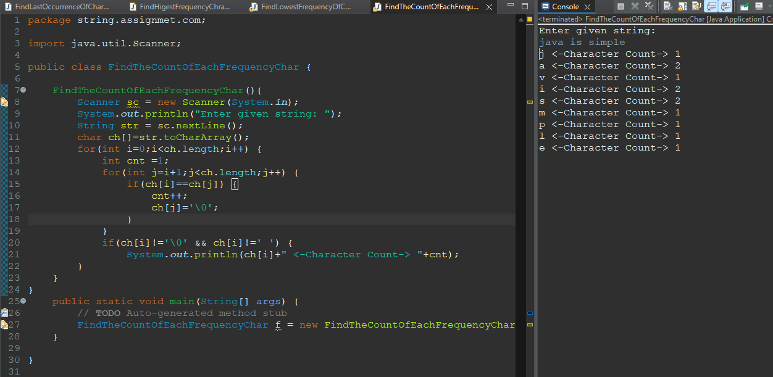

**Q5.Write a Java program to remove first occurrence of a character from string.**

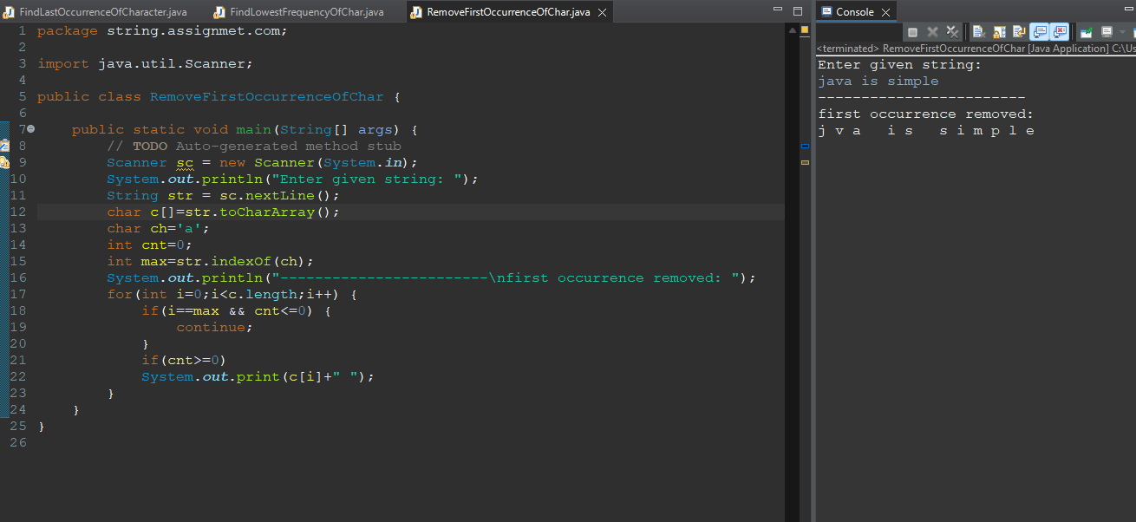

**Q6.Write a Java program to remove last occurrence of a character from string.**

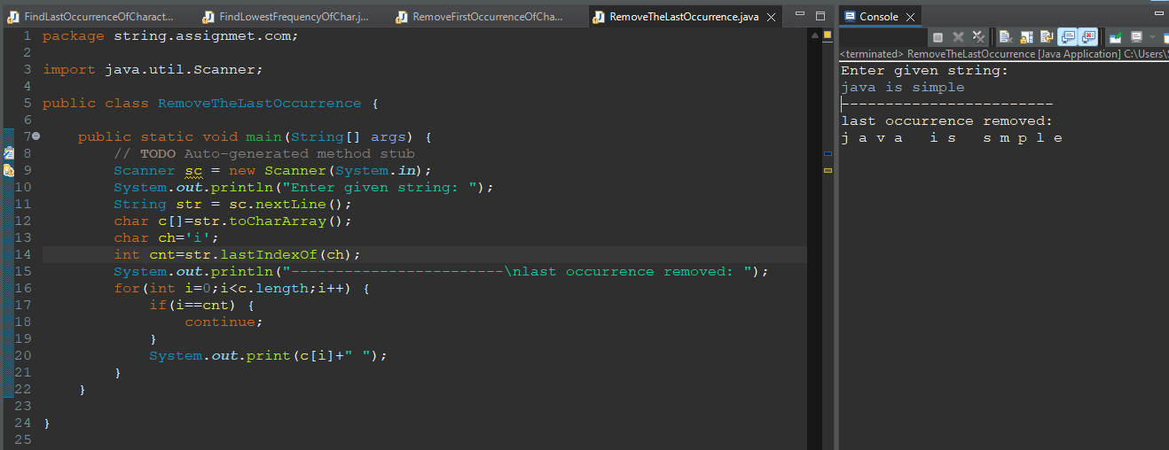

**Q7.Write a Java program to remove all repeated characters from a given string.**

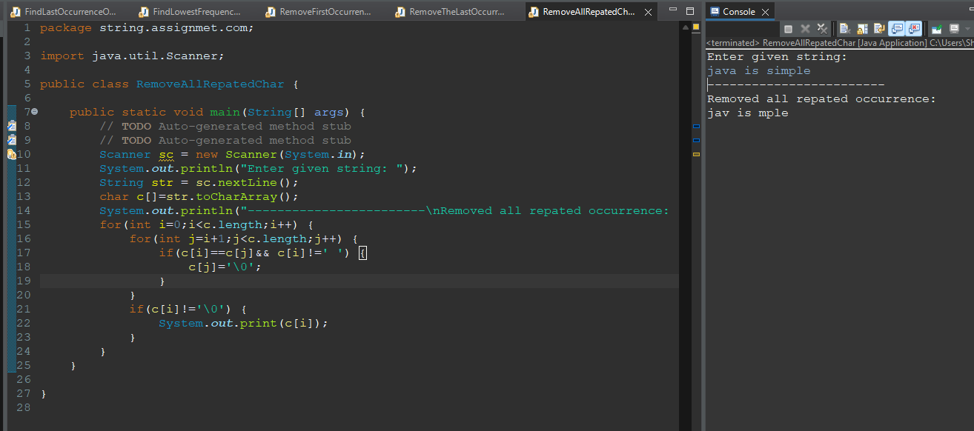

**Q8.Write a Java program to replace first occurrence of a character with another in a string.**

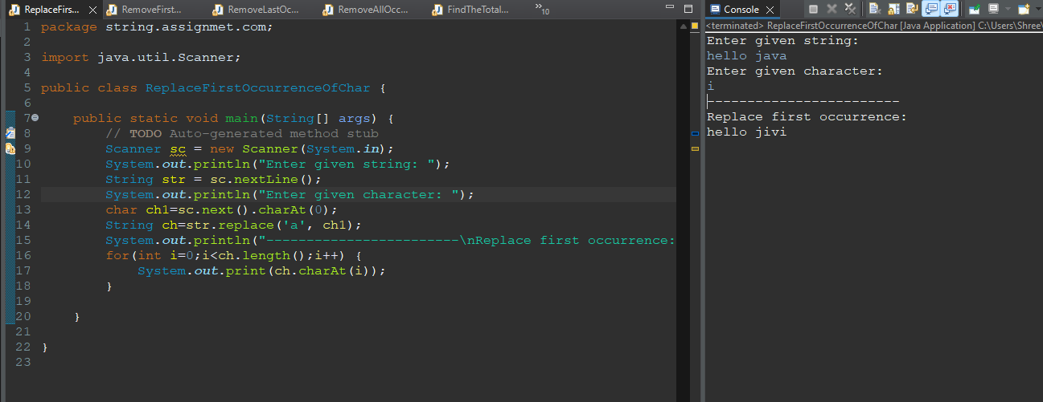

**Q9.Write a Java program to replace last occurrence of a character with another in a string.**

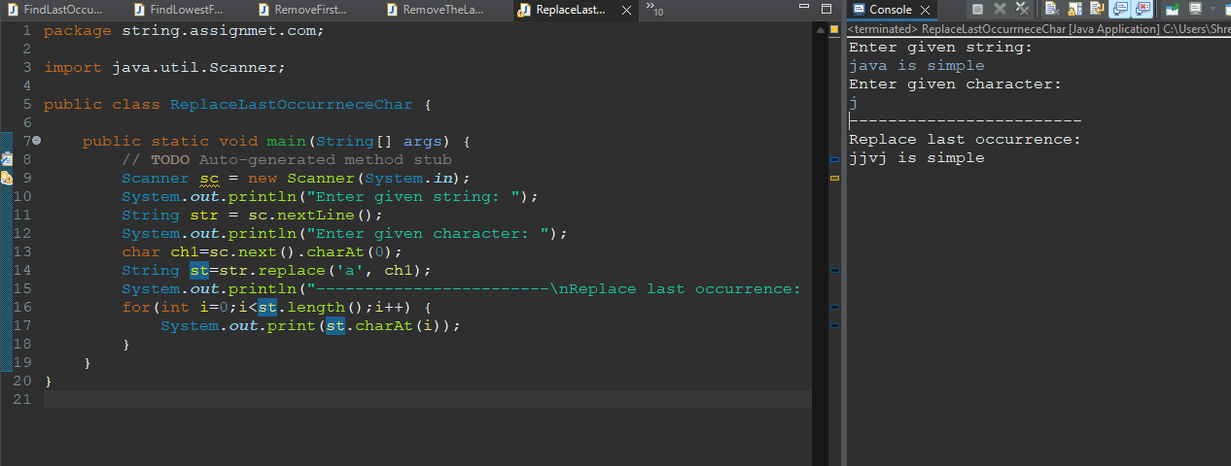

**Q10.Write a Java program to replace all occurrences of a character with another in a string.**

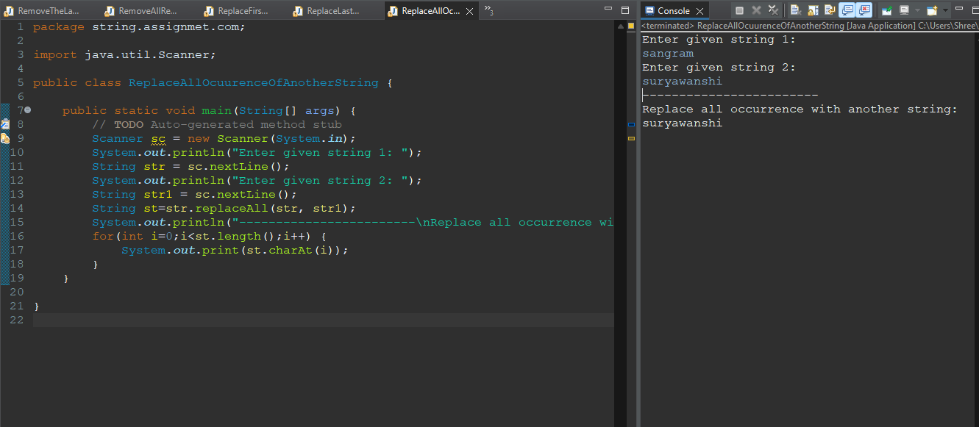

**Q11.Write a Java program to find last occurrence of a word in a given string.**

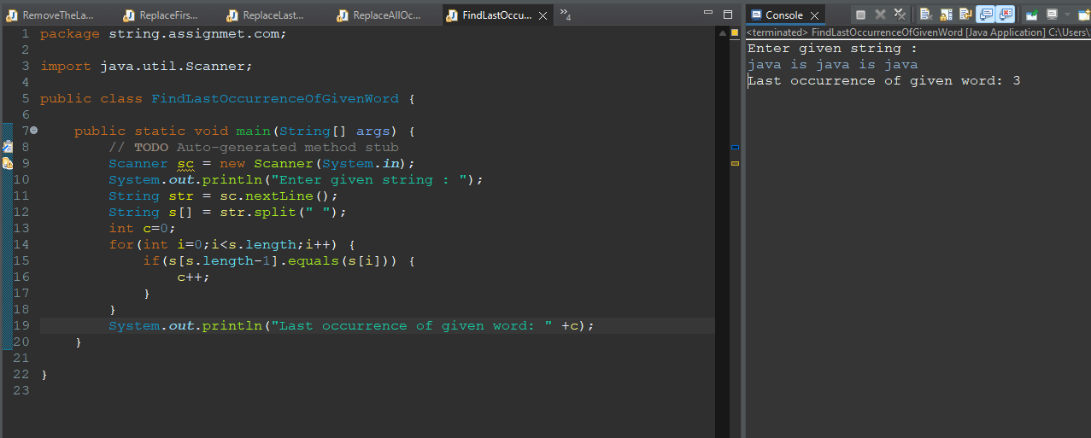

**Q12.Write a Java program to search all occurrences of a word in given string.**

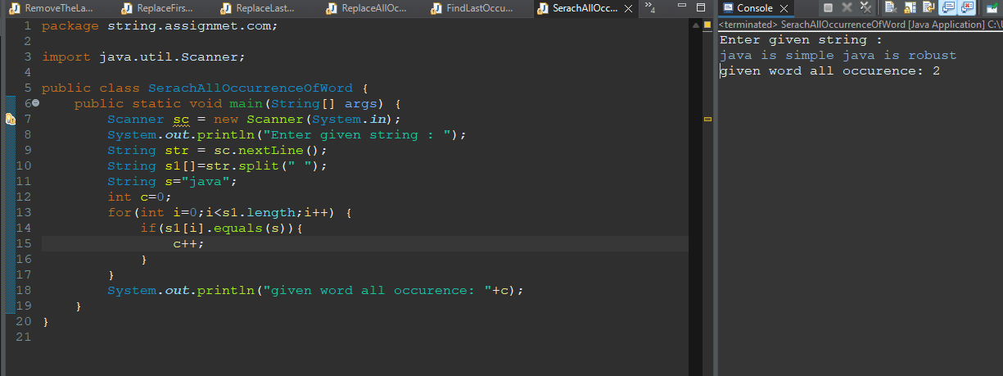

**Q13.Write a Java program to count occurrences of a word in a given string.**

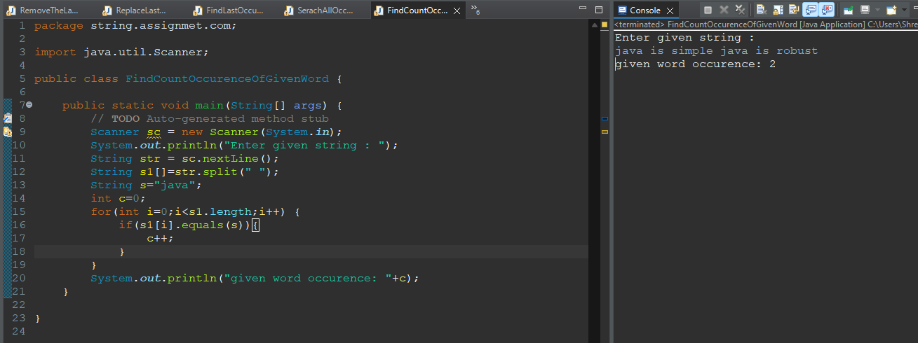

**Q14.Write a Java program to remove first occurrence of a word from string.**

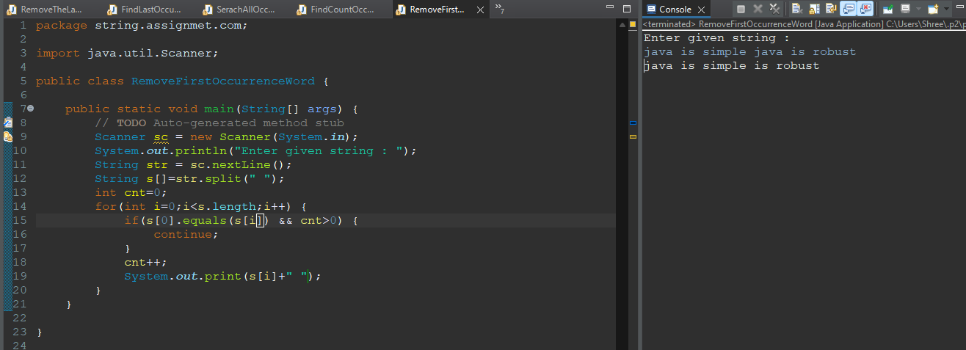

**Q15.Write a Java program to remove last occurrence of a word in given string.**

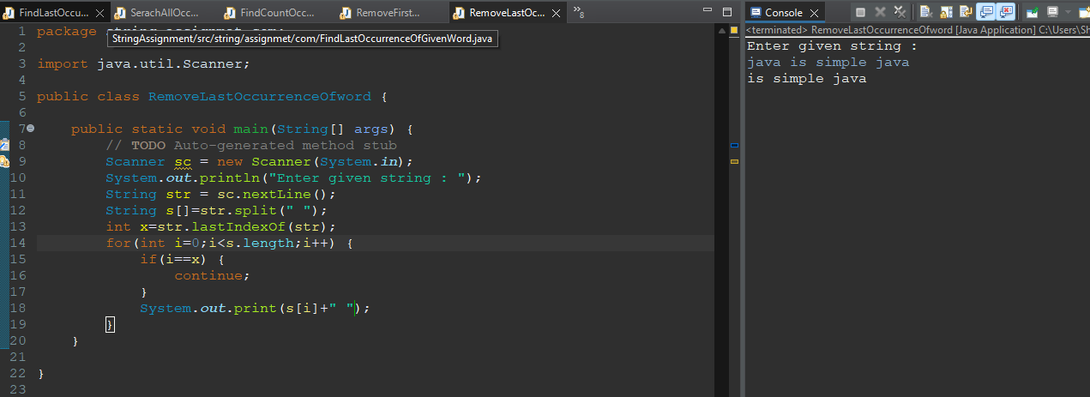

**Q16.Write a Java program to remove all occurrence of a word in given string.**

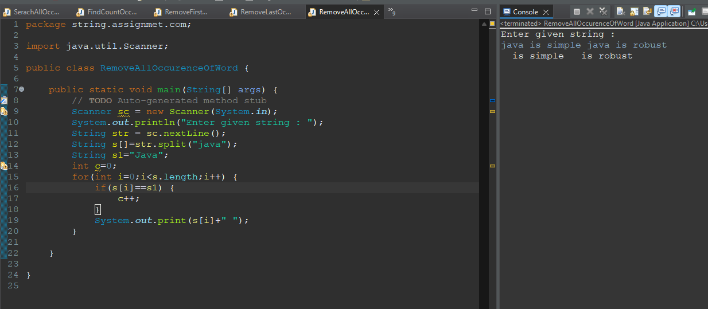

**Q17.Write a Java program to find total number of alphabets, digits or special character in a string.**

